Design Specification

1. Document Information
Field | Value
Project | CAN 2.0B Controller
Document Type | Design Specification
Engineer | Joshua Quinthino Albuquerque
Version | V3.0
Date | 6 October 2026
Reference Specification | Bosch CAN 2.0B Specification
GIthub repository | https://github.com/JOSHUA5227/CAN.git

1.1 Terminology and Abbreviations
The following terminology and abbreviations are used throughout this specification. The definitions are provided before the functional and register sections so that field names and protocol descriptions have a consistent meaning.
Term | Expanded Meaning | Specification Use
CAN 2.0B | Controller Area Network 2.0B | Classic CAN protocol variant supporting standard and extended identifiers.
APB | Advanced Peripheral Bus | Host-side peripheral bus used to access the controller registers.
PCLK | APB/Peripheral Clock | Clock for the APB register interface and PCLK-side CDC logic.
CAN_CLK | CAN Controller Clock | Clock for the CAN protocol engine, timing engine, TX/RX datapath and fault confinement.
BRP | Baud Rate Prescaler | Divider that determines the number of CAN_CLK cycles in one Time Quantum.
SJW | Synchronization Jump Width | Maximum number of TQs by which phase timing may be corrected during resynchronization.
TQ | Time Quantum | Basic unit of CAN bit timing generated by the BRP divider.
SOF | Start of Frame | Dominant bit that marks the beginning of a CAN frame.
DLC | Data Length Code | Four-bit field specifying the number of data bytes in a classic CAN data frame; this design supports 0–8 for TX.
RTR | Remote Transmission Request | Frame-control bit distinguishing data frames from remote frames.
SRR | Substitute Remote Request | Recessive bit in an extended CAN frame that occupies the arbitration position corresponding to the RTR bit in a standard frame.
CRC | Cyclic Redundancy Check | Error-detection field and calculation used to validate the CAN frame.
EOF | End of Frame | Seven recessive bits marking the end of a CAN frame.
ACK | Acknowledgement | Two-bit field containing the ACK slot and ACK delimiter.
IDE | Identifier Extension | Bit indicating standard (11-bit) or extended (29-bit) identifier format.
TEC | Transmit Error Counter | CAN fault-confinement counter tracking transmit-related errors.
REC | Receive Error Counter | CAN fault-confinement counter tracking receive-related errors.
FSM | Finite State Machine | Enumerated state-based control logic used by the frame controller and fault-confinement controller.
FIFO | First-In, First-Out | Buffer in which frames are removed in the same order in which they were accepted.
CDC | Clock Domain Crossing | Logic used to safely transfer information between unrelated clock domains.
RX | Receive / Receiver | CAN receive path or receiving node.
TX | Transmit / Transmitter | CAN transmit path or transmitting node.
SYNC_SEG | Synchronization Segment | Fixed one-TQ segment at the beginning of each nominal CAN bit.
PROP_SEG | Propagation Segment | Timing segment used to compensate for propagation delay in the CAN network.
PHASE_SEG1 | Phase Segment 1 | First phase-buffer segment; its runtime length may be extended during early resynchronization.
PHASE_SEG2 | Phase Segment 2 | Second phase-buffer segment; its runtime length may be shortened during late resynchronization.
TSEG1 | Time Segment 1 | Combined PROP_SEG + PHASE_SEG1 portion of the CAN bit.
TSEG2 | Time Segment 2 | PHASE_SEG2 portion of the CAN bit after the sample point.
APB4 | Advanced Peripheral Bus version 4 | APB protocol version used by the host interface.
R/W | Read/Write | Register access type allowing both reads and writes.
RO | Read Only | Register field that can be read but not written by the host.
WO | Write Only | Register field that can be written but does not return a stored value on read.
R/W1C | Read/Write, Write One to Clear | Access convention in which writing a 1 clears a latched status bit; used as a terminology definition even where a particular register may use another clear mechanism.
FF | Flip-Flop | Sequential storage element.
2-FF | Two Flip-Flop Synchronizer | Two-stage synchronizer used to reduce metastability risk when a single-bit signal crosses a clock domain.
LSB | Least Significant Bit | Lowest-order bit of a vector or field.
MSB | Most Significant Bit | Highest-order bit of a vector or field.
ID | Identifier | CAN frame arbitration identifier.
STD | Standard CAN Format | CAN frame format using an 11-bit identifier.
EXT | Extended CAN Format | CAN frame format using a 29-bit identifier.
CRC_DELIM | CRC Delimiter | Single recessive bit following the CRC sequence.
ACK_DELIM | ACK Delimiter | Single recessive bit following the ACK slot.
BUS_OFF | CAN Bus-Off Error State | Fault-confinement state in which the node stops participating on the bus until recovery.
ERROR_ACTIVE | CAN Error-Active State | Normal fault-confinement state in which active error flags may be transmitted.
ERROR_PASSIVE | CAN Error-Passive State | Fault-confinement state in which passive error flags are transmitted and additional transmission restrictions apply.
RX_FIFO | Receive FIFO | Dual-clock FIFO used to buffer accepted received CAN frames for APB-side software access.
TX_FIFO | Transmit FIFO | Transmit queue terminology; no TX FIFO is implemented in this design, which supports one outstanding TX descriptor.
BRP_COUNT | Baud Rate Prescaler Counter | CAN_CLK-domain counter used to generate the TQ enable event.
TQ_COUNT | Time Quantum Counter | CAN_CLK-domain counter tracking the current TQ position within the CAN bit.

2. Overview
The CAN 2.0B Controller is a synthesizable digital IP block that implements a Bosch CAN 2.0B (ISO 11898) protocol engine with an APB4 register interface. It connects to a host bus through a standard APB4 slave port (PCLK domain) and to a physical CAN transceiver through a single-wire differential-equivalent digital pair, can_tx and can_rx (CAN_CLK domain). Its core function is to serialize and deserialize CAN frames: it arbitrates for bus access, transmits and receives standard (11-bit) and extended (29-bit) data and remote frames, performs bit stuffing/de-stuffing, computes and checks the CRC-15, drives/monitors the acknowledge slot, implements Bosch fault confinement (error-active, error-passive, bus-off with the 128×11 bit-time recovery sequence), and buffers accepted receive frames in a dual-clock FIFO drained by the host through the APB interface. A DV engineer verifying this block is verifying: register-level configuration and control of the core, correct framing/arbitration/CRC/stuffing/ACK behavior on the CAN bus, fault-confinement state transitions and error counter behavior, and correct clock-domain crossing of configuration, transmit requests, receive data, and error/status information between the APB and CAN clock domains.
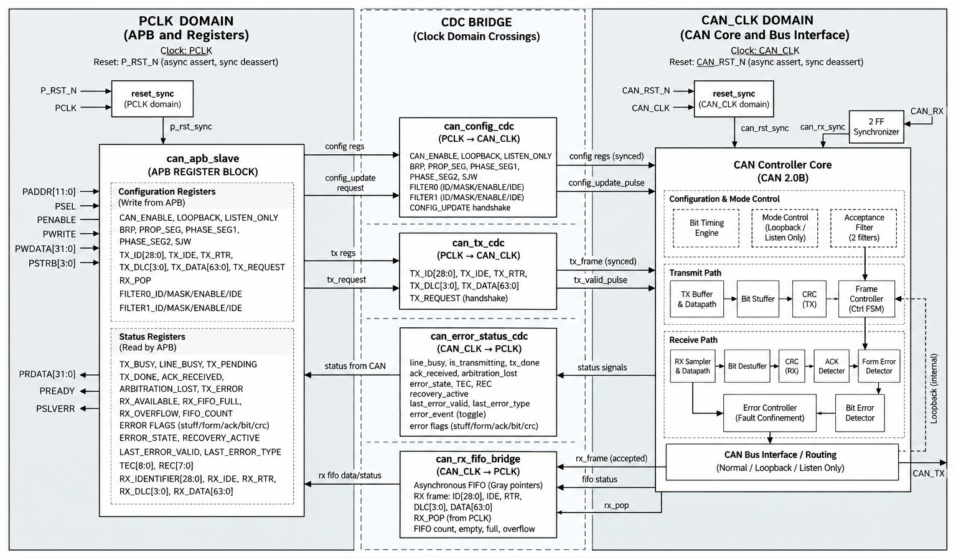
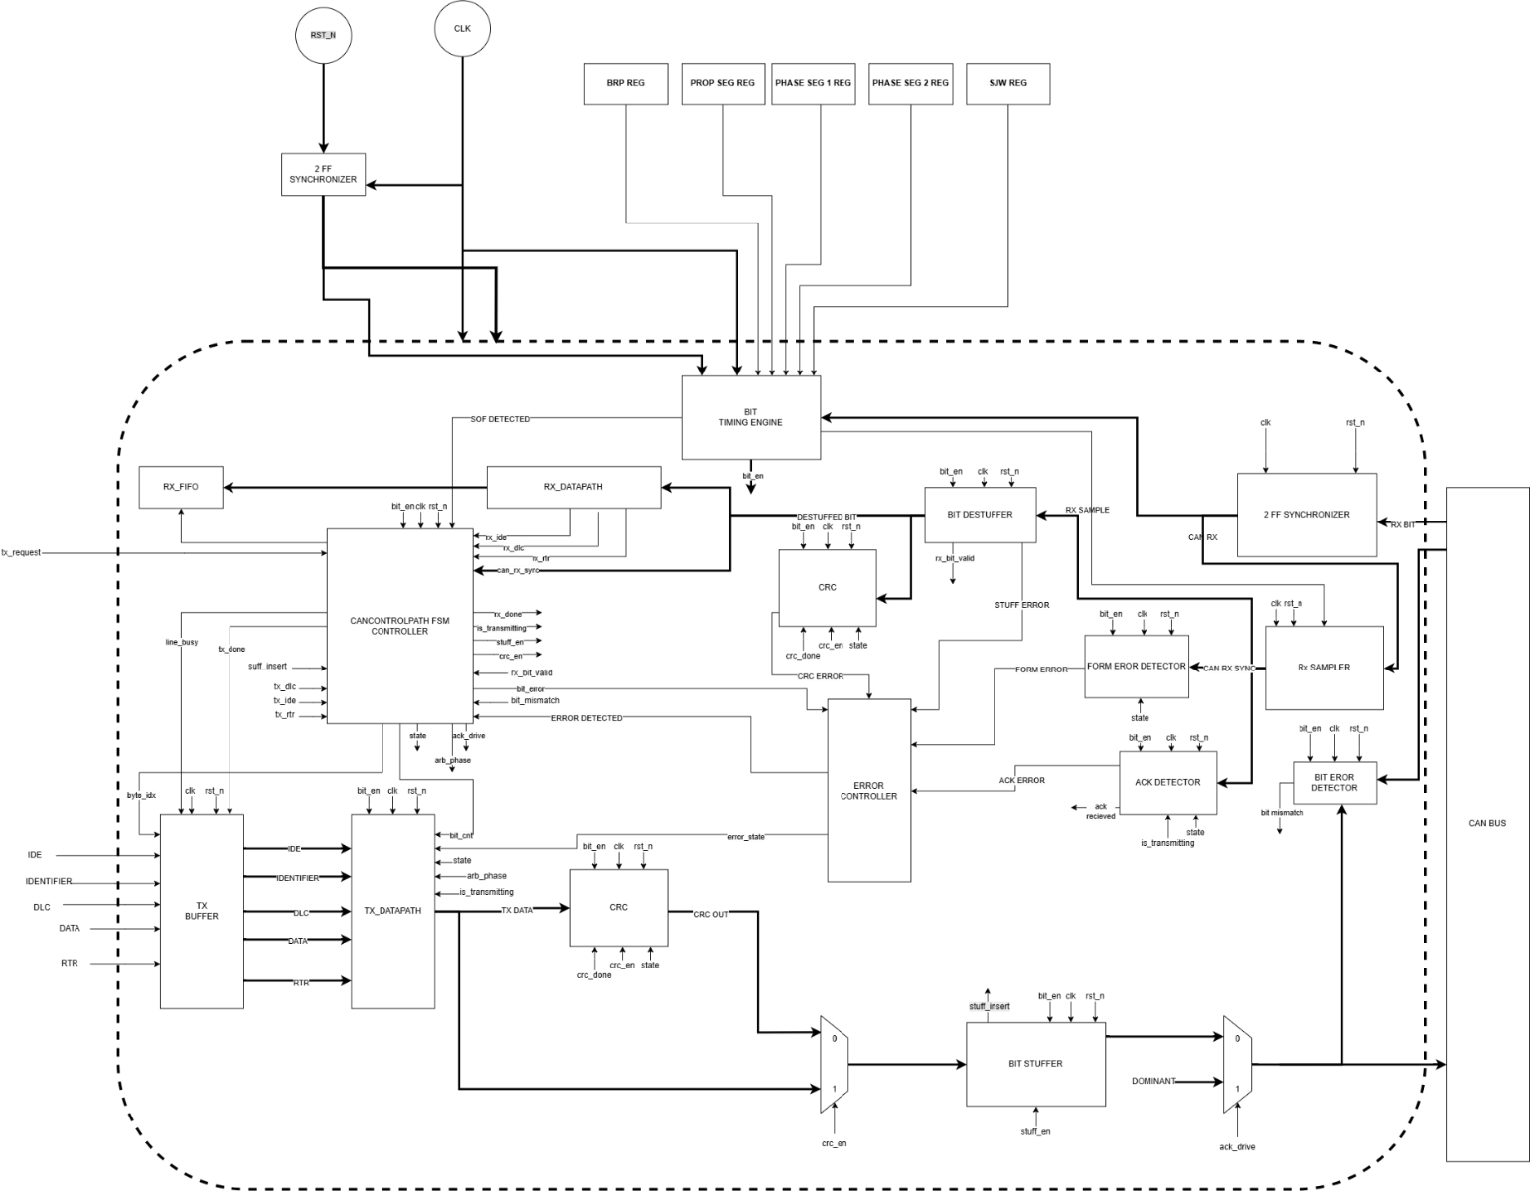

3. Interfaces
Top-level module: can_controller_top. Parameters: CAN_CLK_FREQ, CAN_BIT_RATE, FIFO_DEPTH (see Section 9).
Signal | Dir | Width | Description
pclk | Input | 1 | APB register-interface clock. Clocks all can_apb_slave registers and the PCLK side of every clock-domain crossing.
p_rst_n | Input | 1 | Asynchronous active-low reset for the PCLK domain. Internally synchronized (see Section 4).
can_clk | Input | 1 | CAN protocol-engine clock. Clocks the bit-timing engine, TX/RX serial datapath, stuffer/destuffer, CRC, ACK detector, and fault-confinement logic.
can_rst_n | Input | 1 | Asynchronous active-low reset for the CAN_CLK domain. Internally synchronized (see Section 4).
PADDR | Input | [11:0] | APB4 address bus (pclk domain).
PSEL | Input | 1 | APB4 slave select (pclk domain).
PENABLE | Input | 1 | APB4 enable, second cycle of an APB transfer (pclk domain).
PWRITE | Input | 1 | APB4 write/read select: 1 = write, 0 = read (pclk domain).
PWDATA | Input | [31:0] | APB4 write data (pclk domain).
PSTRB | Input | [3:0] | APB4 write strobes, one bit per byte lane of PWDATA (pclk domain).  PSTRB = 4'b0000: The APB write is accepted with no register modification. No PSLVERR is generated solely because all byte strobes are deasserted.
PRDATA | Output | [31:0] | APB4 read data (pclk domain). Combinational function of the addressed register.
PREADY | Output | 1 | APB4 ready. Always driven 1'b1 in this design: the slave never inserts wait states (pclk domain).
PSLVERR | Output | 1 | APB4 slave error. Asserted combinationally on illegal writes (see Section 5) (pclk domain).
can_rx | Input | 1 | Serial CAN receive line from the transceiver (can_clk domain, asynchronous to can_clk; internally double-flop synchronized).
can_tx | Output | 1 | Serial CAN transmit line to the transceiver (can_clk domain). Driven recessive (1) at reset, in IDLE, and whenever LISTEN_ONLY is set.

No interrupt output exists on this block; all status and error information is exposed only through the STATUS, ERROR_STATUS, TX_STATUS and RX_STATUS registers and must be polled by the host (see Section 10).

4. Clocking and Reset

4.1 Clocks
- PCLK — 50 MHz typical design assumption. The design is frequency-agnostic with respect to PCLK, and PCLK is asynchronous to CAN_CLK; no fixed frequency relationship is assumed or enforced by the RTL.
- can_clk — drives the bit-timing engine, the TX/RX serial datapath (frame controller, stuffer, destuffer, CRC, ACK detector, bit/form-error detectors), and the fault-confinement (error) controller. One CAN time quantum is generated every BRP can_clk cycles (Section 6.1); the actual CAN bit rate is therefore fully determined at run time by the BRP/PROP_SEG/PHASE_SEG1/PHASE_SEG2 registers, not by the CAN_CLK_FREQ/CAN_BIT_RATE parameters (see Section 9).

4.2 Reset
Both resets, p_rst_n and can_rst_n, are asynchronous, active-low. Each is passed through its own two-flop reset_sync synchronizer, instantiated once per clock domain in can_controller_top, producing an internal synchronized reset (p_rst_sync / can_rst_sync) for that domain: assertion is asynchronous (takes effect on the next edge of the reset signal itself), de-assertion is synchronized to two edges of the local clock before downstream logic sees the reset released. Every sequential element observed in the RTL (bit-timing counters, the frame-controller and fault-confinement state registers, TX/RX datapath registers, CRC registers, CDC handshake registers, and the async-FIFO pointers) is reset by one of these two synchronized resets.
The APB (pclk) and CAN protocol (can_clk) domains use independent reset inputs, p_rst_n and can_rst_n. Resetting only one domain does not automatically reset the other domain. Because configuration, TX descriptors, RX FIFO state, and error/status information cross between the two clock domains through CDC structures, software or system-level reset control must ensure that both domains are brought to a known state before normal communication is resumed.
If only the APB/pclk domain is reset while the CAN domain remains active, CAN-side protocol state and bus activity may continue while the APB-side register and CDC state is reset. Any in-flight APB-to-CAN transaction or previously pending software-visible state must therefore not be assumed to survive the reset.
If only the CAN/can_clk domain is reset while the APB domain remains active, the CAN protocol engine, TX/RX datapath, fault-confinement state, and CAN-side CDC state are reset while APB-side software-visible registers remain accessible. Configuration and pending transactions should therefore be re-established after the CAN-domain reset before normal CAN operation is resumed. For deterministic system initialization and recovery, both p_rst_n and can_rst_n should be asserted and released before normal controller operation is started. The design does not provide an automatic cross-domain reset handshake that forces one domain to reset when the other domain is reset.

4.3 Clock-Domain Crossings
Crossing | Direction | Structure
Configuration snapshot (CAN_ENABLE, LOOPBACK, LISTEN_ONLY, BRP, PROP_SEG, PHASE_SEG1, PHASE_SEG2, SJW, both acceptance filters) | pclk → can_clk | can_config_cdc — request/acknowledge toggle handshake (2-FF synchronized in each direction) that transfers the entire configuration as one atomic snapshot.
TX descriptor (TX_ID, TX_IDE, TX_RTR, TX_DLC, TX_DATA, TX_COMMAND strobe) | pclk → can_clk | can_tx_cdc — request/acknowledge toggle handshake, same style as the configuration CDC; one TX descriptor in flight at a time (p_tx_pending held until acknowledged).
Received frame data (identifier, IDE, RTR, DLC, data) | can_clk → pclk | can_rx_fifo_bridge, built on async_fifo — a dual-clock, Gray-code pointer FIFO, 128 bits wide, FIFO_DEPTH entries deep.
Error/status snapshot (TEC, REC, error_state, recovery_active, last_error_type/valid, line_busy, is_transmitting, tx_done, ack_received, arbitration_lost, and the five error-event flags) | can_clk → pclk | can_error_status_cdc — toggle-qualified snapshot capture, structurally the mirror of the configuration CDC.
can_rx (external asynchronous bus input) | async → can_clk | can_rx_sync — two-flop synchronizer inside can_controller; no logic in the design touches the raw pin.
rx_overflow (sticky FIFO-overflow flag, generated in can_clk domain) | can_clk → pclk | Dedicated 2-FF synchronizer inside can_apb_slave. (The FIFO's full/empty/count flags used elsewhere are already generated natively in the pclk domain by the async FIFO itself.)

4.4 Sticky and Live Status Semantics

Definitions used by the register map
Status fields are classified as either sticky or live. This classification describes how an event is retained and how software observes it after the event crosses from the CAN_CLK domain into the PCLK domain.
Sticky fields retain an event indication after the event occurs until their defined clear condition. A sticky field is therefore intended for software polling because the event does not disappear merely because the host was not sampling the register on the exact CAN clock cycle in which the event occurred. In this design, TX_DONE, TX_ACK_RECEIVED, TX_ARBITRATION_LOST and TX_ERROR are sticky until a new TX_COMMAND clears them; RX_OVERFLOW is sticky from the first FIFO-overflow event until reset; and LAST_ERROR_VALID/LAST_ERROR_TYPE retain the most recently latched error/event record until overwritten by a newer event or reset.
Live fields represent the current event condition rather than a retained history. A live event may be asserted for only a single synchronized PCLK cycle and is not latched for later polling. In this design, ARB_LOST, ACK_ERROR, CRC_ERROR, STUFF_ERROR, FORM_ERROR and BIT_ERROR in STATUS are live, single-cycle event indications. Software that needs guaranteed event retention should use the corresponding sticky TX_STATUS or latched ERROR_STATUS information where applicable.
CDC behavior does not change the semantic classification: sticky information is transferred as retained state/snapshot information, while live event indications are transferred as synchronized event pulses. The host must therefore treat live status fields as transient and sticky fields as historical state.
Type | Meaning | Software Observation | Examples in this design
Sticky | Event indication remains asserted after the originating event until the specified clear condition. | Safe for polling; event can be observed after it occurred. | TX_DONE, TX_ACK_RECEIVED, TX_ARBITRATION_LOST, TX_ERROR, RX_OVERFLOW.
Live | Event indication reflects an event occurring at or around the current synchronized cycle and is not retained. | May be missed by slow polling; intended for immediate/event-cycle observation. | ARB_LOST, ACK_ERROR, CRC_ERROR, STUFF_ERROR, FORM_ERROR, BIT_ERROR in STATUS.
Latched record | A retained record stores the most recent event type and a valid indication. | Read to determine the latest recorded event; a newer event replaces the previous record. | LAST_ERROR_VALID and LAST_ERROR_TYPE.

5. Register Map
All registers are accessed through the APB4 slave (can_apb_slave, ADDR_WIDTH = 12). All registers are 32 bits wide, word-aligned, and byte-strobe (PSTRB) qualified on writes. PREADY is always asserted the same cycle (zero-wait-state slave). Unmapped addresses read as 0 and accept writes with no effect and no error. PSLVERR is asserted, and the write is discarded, in exactly the cases noted below.

Register Map
Register | Offset | Width | Description
VERSION | 0x000 | 32-bit | Fixed identification / version code
CONTROL | 0x004 | 32-bit | Core enable, loopback and listen-only mode control
STATUS | 0x008 | 32-bit | Line busy, TX/RX flags and live error pulses
ERROR_STATUS | 0x00C | 32-bit | Error state, bus-off recovery and last-error record
BRP | 0x010 | 32-bit | Baud-rate prescaler (time-quantum length)
SEGMENTS | 0x014 | 32-bit | Propagation and phase segment lengths
SJW_CONTROL | 0x018 | 32-bit | Synchronization jump width
TX_ID | 0x01C | 32-bit | Identifier of the frame to transmit
TX_CTRL | 0x020 | 32-bit | TX frame format (IDE, RTR) and data length code
TX_DATA_LO | 0x024 | 32-bit | TX data holding register, lower 32 bits
TX_DATA_HI | 0x028 | 32-bit | TX data holding register, upper 32 bits
TX_COMMAND | 0x02C | 32-bit | Submits the queued frame for transmission
TX_STATUS | 0x030 | 32-bit | Transmission progress and result flags
RX_STATUS | 0x034 | 32-bit | RX FIFO level and status flags
RX_ID | 0x038 | 32-bit | Identifier of the frame at the RX FIFO head
RX_CTRL | 0x03C | 32-bit | IDE, RTR and DLC of the frame at the RX FIFO head
RX_DATA_LO | 0x040 | 32-bit | Received data, lower 32 bits
RX_DATA_HI | 0x044 | 32-bit | Received data, upper 32 bits
RX_COMMAND | 0x048 | 32-bit | Discards the frame at the RX FIFO head
FILTER0_ID | 0x04C | 32-bit | Acceptance filter 0 compare value
FILTER0_MASK | 0x050 | 32-bit | Acceptance filter 0 mask
FILTER0_CTRL | 0x054 | 32-bit | Filter 0 enable and IDE match
FILTER1_ID | 0x058 | 32-bit | Acceptance filter 1 compare value
FILTER1_MASK | 0x05C | 32-bit | Acceptance filter 1 mask
FILTER1_CTRL | 0x060 | 32-bit | Filter 1 enable and IDE match
TEC | 0x064 | 32-bit | Transmit error counter
REC | 0x068 | 32-bit | Receive error counter

1. VERSION Register – Offset 0x000
Field | Bits | Access | Reset | Description
VERSION | 31:0 | RO | 0x0100_2001 | Fixed, read-only identification/version code. Writes have no effect.

2. CONTROL Register – Offset 0x004
Field | Bits | Access | Reset | Description
CAN_ENABLE | 0 | RW | 0 | 1 = enable the core (bit-timing engine and protocol FSM run); 0 = core held in IDLE/disabled. A write that clears this bit while CAN line is busy, (tx_busy) is rejected with PSLVERR and the register is left unchanged.  May be asserted using the existing configuration or together with updated configuration fields in the same APB transaction; the controller operates using the resulting programmed configuration.
LOOPBACK | 1 | RW | 0 | 1 = internal loopback mode (Section 6.9).
LISTEN_ONLY | 2 | RW | 0 | 1 = listen-only/monitor mode (Section 6.9). A single write that sets LOOPBACK and LISTEN_ONLY together is rejected with PSLVERR and the register is left unchanged.
Reserved | 31:3 | RO | 0 | Reads as 0.

3. STATUS Register – Offset 0x008
Field | Bits | Access | Reset | Description
TX_BUSY | 0 | RO | 0 | Bus/line busy — a frame (TX or RX) is currently in progress.
TX_DONE | 1 | RO | 0 | Sticky: a transmission completed since the last write to TX_COMMAND. Cleared by writing TX_COMMAND (Section 5).
RX_AVAILABLE | 2 | RO | 0 | RX FIFO holds at least one complete frame.
RX_FIFO_FULL | 3 | RO | 0 | RX FIFO is full (pclk-domain flag from the async FIFO).
ARB_LOST | 4 | RO | 0 | Live, single-cycle pulse: arbitration was lost on the most recent can_clk cycle in which it occurred. Not latched — see Section 10.
ACK_ERROR | 5 | RO | 0 | Live, single-cycle pulse (not latched).
CRC_ERROR | 6 | RO | 0 | Live, single-cycle pulse (not latched).
STUFF_ERROR | 7 | RO | 0 | Live, single-cycle pulse (not latched).
FORM_ERROR | 8 | RO | 0 | Live, single-cycle pulse (not latched).
BIT_ERROR | 9 | RO | 0 | Live, single-cycle pulse (not latched).
RX_OVERFLOW | 10 | RO | 0 | Sticky: the RX FIFO was written while full at least once since reset. Never cleared by hardware — see Section 10.
Reserved | 31:11 | RO | 0 | Reads as 0.

4. ERROR_STATUS Register – Offset 0x00C
Field | Bits | Access | Reset | Description
ERROR_STATE | 1:0 | RO | 0 | 0 = Error Active, 1 = Error Passive, 2 = Bus Off, 3 = unused.
RECOVERY_ACTIVE | 2 | RO | 0 | 1 while the bus-off recovery sequence (Section 6.8) is in progress.
LAST_ERROR_VALID | 3 | RO | 0 | 1 once at least one error/event has been latched since reset.
LAST_ERROR_TYPE | 7:4 | RO | 0 | Type of the most recently latched error/event: 0 none, 1 bit error, 2 stuff error, 3 CRC error, 4 form error, 5 ACK error, 6 arbitration lost (arbitration loss is recorded as an event, not a CAN error; see Section 6.8).
Reserved | 31:8 | RO | 0 | Reads as 0.

5. BRP Register – Offset 0x010
Field | Bits | Access | Reset | Description
BRP | 31:0 | RW | 0 | Baud-rate prescaler. One CAN time quantum = BRP × can_clk periods. Rejected with PSLVERR (register unchanged) if CAN_ENABLE = 1. Must be programmed before enabling the core; BRP = 0 is not a valid divide value (Section 6.1, Section 10).

6. SEGMENTS Register – Offset 0x014
Field | Bits | Access | Reset | Description
PROP_SEG | 7:0 | RW | 0 | Propagation segment length, in time quanta.
PHASE_SEG1 | 15:8 | RW | 0 | Phase-buffer segment 1 length, in time quanta.
PHASE_SEG2 | 23:16 | RW | 0 | Phase-buffer segment 2 length, in time quanta.
Reserved | 31:24 | RO | 0 | Reads as 0. Whole register rejected with PSLVERR (unchanged) if CAN_ENABLE = 1.

7. SJW_CONTROL Register – Offset 0x018
Field | Bits | Access | Reset | Description
SJW | 3:0 | RW | 0 | Synchronization jump width, in time quanta; caps the per-bit resynchronization correction (Section 6.1). Rejected with PSLVERR (unchanged) if CAN_ENABLE = 1.
Reserved | 31:4 | RO | 0 | Reads as 0.

8. TX_ID Register – Offset 0x01C
Field | Bits | Access | Reset | Description
TX_IDENTIFIER | 28:0 | RW | 0 | Frame identifier to transmit next. When TX_IDE = 0, only bits [10:0] are used (standard 11-bit ID). When TX_IDE = 1, the full 29 bits are used: bits [28:18] are the 11-bit base ID and bits [17:0] are the 18-bit ID extension.

9. TX_CTRL Register – Offset 0x020
Field | Bits | Access | Reset | Description
TX_IDE | 0 | RW | 0 | 0 = standard (11-bit) frame, 1 = extended (29-bit) frame.
TX_RTR | 1 | RW | 0 | 1 = transmit as a remote frame (no data field driven, regardless of TX_DLC).
TX_DLC | 5:2 | RW | 0 | Data length code in bytes for the frame to transmit. Values 0–8 are only supported;
Reserved | 31:6 | RO | 0 | Reads as 0.

10. TX_DATA_LO Register – Offset 0x024
Field | Bits | Access | Reset | Description
TX_DATA[31:0] | 31:0 | RW | 0 | Lower 32 bits of the 64-bit TX data holding register (Section 6.2 for byte ordering).

11. TX_DATA_HI Register – Offset 0x028
Field | Bits | Access | Reset | Description
TX_DATA[63:32] | 31:0 | RW | 0 | Upper 32 bits of the 64-bit TX data holding register.

12. TX_COMMAND Register – Offset 0x02C
Field | Bits | Access | Reset | Description
TX_START | 0 | WO | — | Write 1 to submit the frame currently held in TX_ID/TX_CTRL/TX_DATA for transmission. Self-clearing (reads as 0). Also clears the sticky bits in TX_STATUS (TX_DONE, TX_ACK_RECEIVED, TX_ARBITRATION_LOST, TX_ERROR) as a side effect of starting a new attempt.
Reserved | 31:1 | RO | 0 | Reads as 0.

13. TX_STATUS Register – Offset 0x030
Field | Bits | Access | Reset | Description
TX_PENDING | 0 | RO | 0 | A TX has been requested and is queued in the pclk-side CDC handshake, but has not yet been accepted into the CAN-domain TX buffer.
TX_BUSY | 1 | RO | 0 | Alias of line_busy, synchronized into the pclk domain.
TX_DONE | 2 | RO | 0 | Sticky. Cleared by writing TX_COMMAND.
TX_ACK_RECEIVED | 3 | RO | 0 | Sticky. Cleared by writing TX_COMMAND.
TX_ARBITRATION_LOST | 4 | RO | 0 | Sticky. Cleared by writing TX_COMMAND.
TX_ERROR | 5 | RO | 0 | Sticky OR of ACK/CRC/stuff/form/bit error observed during the transmission attempt. Cleared by writing TX_COMMAND.
Reserved | 31:6 | RO | 0 | Reads as 0.

14. RX_STATUS Register – Offset 0x034
Field | Bits | Access | Reset | Description
FIFO_COUNT | 7:0 | RO | 0 | Number of complete frames currently held in the RX FIFO.
RX_EMPTY | 8 | RO | 1 | Inverse of RX_AVAILABLE.
RX_FIFO_FULL | 9 | RO | 0 | Same flag as STATUS bit 3.
RX_OVERFLOW | 10 | RO | 0 | Same sticky flag as STATUS bit 10.
Reserved | 31:11 | RO | 0 | Reads as 0.

15. RX_ID Register – Offset 0x038
Field | Bits | Access | Reset | Description
RX_IDENTIFIER | 28:0 | RO | 0 | Identifier of the frame at the head of the RX FIFO, same base/extension convention as TX_ID.

16. RX_CTRL Register – Offset 0x03C
Field | Bits | Access | Reset | Description
RX_IDE | 0 | RO | 0 | IDE bit of the frame at the head of the RX FIFO.
RX_RTR | 1 | RO | 0 | RTR bit of the frame at the head of the RX FIFO.
RX_DLC | 5:2 | RO | 0 | DLC of the frame at the head of the RX FIFO.
Reserved | 31:6 | RO | 0 | Reads as 0.

17. RX_DATA_LO Register – Offset 0x040
Field | Bits | Access | Reset | Description
RX_DATA[31:0] | 31:0 | RO | 0 | Lower 32 bits of the received-data register for the frame at the head of the RX FIFO.

18. RX_DATA_HI Register – Offset 0x044
Field | Bits | Access | Reset | Description
RX_DATA[63:32] | 31:0 | RO | 0 | Upper 32 bits of the received-data register.

19. RX_COMMAND Register – Offset 0x048
Field | Bits | Access | Reset | Description
RX_POP | 0 | WO | — | Write 1 to discard the frame at the head of the RX FIFO and advance to the next frame. Should be written only after RX_ID/RX_CTRL/RX_DATA_* have been read. Self-clearing (reads as 0). A write of RX_COMMAND[0] = 1 when the RX FIFO is empty is ignored. No FIFO read occurs, no FIFO pointer is modified, and PSLVERR is not asserted. Software shall check RX_STATUS.RX_EMPTY/RX_AVAILABLE before issuing RXFIFO_POP
Reserved | 31:1 | RO | 0 | Reads as 0.

20. FILTER0_ID Register – Offset 0x04C
Field | Bits | Access | Reset | Description
FILTER0_ID | 28:0 | RW | 0 | Compare value for acceptance filter 0. Rejected with PSLVERR (unchanged) if CAN_ENABLE = 1.

21. FILTER0_MASK Register – Offset 0x050
Field | Bits | Access | Reset | Description
FILTER0_MASK | 28:0 | RW | 0 | Mask for filter 0: 1 = compare this identifier bit, 0 = don't-care. Rejected with PSLVERR (unchanged) if CAN_ENABLE = 1.

22. FILTER0_CTRL Register – Offset 0x054
Field | Bits | Access | Reset | Description
FILTER0_ENABLE | 0 | RW | 0 | 1 = filter 0 participates in acceptance filtering (Section 6.10).
FILTER0_IDE | 1 | RW | 0 | IDE value a frame must have to match filter 0 (0 = standard, 1 = extended).
Reserved | 31:2 | RO | 0 | Reads as 0. Whole register rejected with PSLVERR (unchanged) if CAN_ENABLE = 1.

23. FILTER1_ID Register – Offset 0x058
Field | Bits | Access | Reset | Description
FILTER1_ID | 28:0 | RW | 0 | Compare value for acceptance filter 1. Rejected with PSLVERR (unchanged) if CAN_ENABLE = 1.

24. FILTER1_MASK Register – Offset 0x05C
Field | Bits | Access | Reset | Description
FILTER1_MASK | 28:0 | RW | 0 | Mask for filter 1, same semantics as FILTER0_MASK. Rejected with PSLVERR (unchanged) if CAN_ENABLE = 1.

25. FILTER1_CTRL Register – Offset 0x060
Field | Bits | Access | Reset | Description
FILTER1_ENABLE | 0 | RW | 0 | 1 = filter 1 participates in acceptance filtering.
FILTER1_IDE | 1 | RW | 0 | IDE value a frame must have to match filter 1.
Reserved | 31:2 | RO | 0 | Reads as 0. Whole register rejected with PSLVERR (unchanged) if CAN_ENABLE = 1.

26. TEC Register – Offset 0x064
Field | Bits | Access | Reset | Description
TEC | 8:0 | RO | 0 | Transmit error counter (Section 6.8).

27. REC Register – Offset 0x068
Field | Bits | Access | Reset | Description
REC | 7:0 | RO | 0 | Receive error counter (Section 6.8).

27. PSLVERR Conditions
Condition | PSLVERR | Behavior
Read from write-only register | 0 | Access accepted; PRDATA returns 0.
Write to read-only register | 0 | Write ignored; no error reported.
Read from empty RX FIFO | 0 | No APB error is generated.
Write to reserved/unmapped address | 0 | Write ignored.
Read from reserved/unmapped address | 0 | PRDATA returns 0.
Address above valid register range | 0 | Treated as an unmapped access; no error reported.
Write CAN_ENABLE=0 while the CAN line is busy (TX or RX frame in progress) | 1 | Write rejected and PSLVERR asserted.
Set LOOPBACK=1 and LISTEN_ONLY=1 simultaneously | 1 | Invalid operating-mode combination; write rejected.
Modify BRP while CAN is enabled | 1 | Configuration write rejected.
Modify SEGMENTS while CAN is enabled | 1 | Configuration write rejected.
Modify SJW_CONTROL while CAN is enabled | 1 | Configuration write rejected.
Modify any filter register while CAN is enabled | 1 | Filter configuration write rejected.
Invalid BRP/SEGMENTS/SJW field value | 0 | No field-range validation is performed by the APB slave.
Invalid filter field value | 0 | No general field-value validation is performed by the APB slave.
Valid APB access | 0 | Access completes normally.
Reserved bits set in an otherwise valid writable register | 0 | No general reserved-bit validation is implemented; reserved bits are ignored.

5.1 APB Integration and Quick-Start Procedure
The CAN controller is configured and controlled from the host side through the APB4-style interface of can_controller_top. This procedure describes the top-level integration path: APB register accesses, configuration propagation, controller enable, and host-visible transmit/receive operations. Lower-level can_controller interfaces and verification testbench behavior are outside the scope of this procedure.

5.1.1 Initialization Sequence
1. Apply reset. Assert p_rst_n and can_rst_n.
2. Release reset. Deassert the resets and allow the APB and CAN clock domains to leave reset.
3. Verify APB access. Read VERSION (0x000); CONTROL and STATUS may also be read to confirm the reset state.
4. Program CAN bit timing. Write BRP (0x010), SEGMENTS (0x014), and SJW_CONTROL (0x018) while CAN operation remains disabled.
5. Allow configuration propagation. Allow sufficient PCLK activity for the programmed configuration to cross into the CAN_CLK domain through the configuration CDC path.
6. Enable the controller. Write CONTROL (0x004) with ENABLE=1.
7. Configure transmit data when required. Program TX_ID, TX_CTRL, TX_DATA_LO and TX_DATA_HI through APB before issuing TX_COMMAND.
8. Read received frames when available. Monitor RX_STATUS/STATUS for an available frame, then read RX_ID, RX_CTRL, RX_DATA_LO and RX_DATA_HI and issue RX_COMMAND to consume the entry.

5.1.2 Nominal 100 MHz / 1 Mbps Configuration
For the documented 100 MHz CAN_CLK / 1 Mbps nominal configuration:
Register | Offset | Value | Meaning
BRP | 0x010 | 0x00000001 | BRP = 1
SEGMENTS | 0x014 | 0x00020205 | PROP_SEG = 7, PHASE_SEG1 = 8, PHASE_SEG2 = 4
SJW_CONTROL | 0x018 | 0x00000001 | SJW = 1
CONTROL | 0x004 | 0x00000001 | ENABLE = 1
TQ_BIT = 1 + 7 + 8 + 4 = 20 TQ; CAN_BIT_RATE = 100 MHz / (5 × 20) = 1 Mbps.

5.1.3 APB Register Addressing
The CAN controller uses word-aligned APB register offsets. Register Address = Base Address + Register Offset. For example, if the peripheral is mapped at BASE, STATUS at offset 0x008 is accessed at BASE + 0x008. The design defines the offsets; SoC integration determines the base address.

5.1.4 APB-Side Transmit Flow
A transmit operation begins at the APB host interface and moves from the APB register block into the CAN clock domain through the transmit CDC path. The host supplies a frame descriptor through APB registers and then issues a transmit command; it does not directly drive the CAN serial datapath.

5.1.4.1 Transmit Register Programming
Step | APB Register | Offset | Purpose
1 | TX_ID | 0x01C | CAN identifier
2 | TX_CTRL | 0x020 | IDE, RTR and DLC control
3 | TX_DATA_LO | 0x024 | Lower 32 data bits
4 | TX_DATA_HI | 0x028 | Upper 32 data bits
5 | TX_COMMAND | 0x02C | Request transmission

5.1.4.2 Transmit Data Path
- APB master writes TX_ID, TX_CTRL, TX_DATA_LO and TX_DATA_HI.
- Host writes TX_COMMAND to request transmission.
- The request and descriptor cross PCLK → CAN_CLK through can_tx_cdc.
- CAN-side transmit logic accepts the descriptor when transmission can begin.
- The frame controller performs arbitration and coordinates control, data, CRC, ACK and end-of-frame processing.
- The TX datapath serializes and stuffs the frame before driving can_tx.
- If arbitration is lost, transmission stops and the node continues as a receiver according to CAN arbitration behavior.
- ACK errors or other protocol errors are handled by the CAN error/retransmission logic.
- Completion and error information is propagated back toward the APB domain and is visible through the applicable TX/STATUS registers.
APB-facing TX sequence: TX_ID → TX_CTRL → TX_DATA_LO → TX_DATA_HI → TX_COMMAND → can_tx_cdc → CAN frame controller / TX datapath → can_tx.

5.1.5 APB-Side Receive Flow
A receive operation starts at the CAN bus and terminates at the APB interface. A complete accepted CAN frame crosses from the CAN_CLK domain into the PCLK domain through the asynchronous RX FIFO and is exposed through the APB RX registers.

5.1.5.1 Receive Data Path
- can_rx is synchronized into the CAN_CLK domain.
- The CAN RX datapath decodes identifier, IDE, RTR, DLC and data fields.
- The receiver performs de-stuffing and protocol validation, including CRC, form and stuff checks as applicable.
- Acceptance filtering determines whether the received identifier is accepted.
- An accepted complete frame is written into the dual-clock RX FIFO.
- The RX FIFO transfers the frame into the PCLK domain using the asynchronous FIFO CDC mechanism.
- The APB register block exposes the frame through RX_ID, RX_CTRL, RX_DATA_LO and RX_DATA_HI.
- The host checks RX_STATUS/STATUS, reads the RX registers, and writes RX_COMMAND to consume the current entry according to the implemented register semantics.

5.1.5.2 APB Receive Register Interface
APB Register | Offset | Host-side function
RX_STATUS | 0x034 | Receive-side status
RX_ID | 0x038 | Received CAN identifier
RX_CTRL | 0x03C | Received frame control information
RX_DATA_LO | 0x040 | Lower 32 received data bits
RX_DATA_HI | 0x044 | Upper 32 received data bits
RX_COMMAND | 0x048 | Receive command / entry consumption
APB-facing RX sequence: can_rx → synchronization / RX datapath → de-stuffing and validation → acceptance filter → RX FIFO → PCLK-side FIFO interface → RX_STATUS/RX_ID/RX_CTRL/RX_DATA_LO/RX_DATA_HI → RX_COMMAND.

5.1.5.3 Receive Status and Error Visibility
RX_AVAILABLE indicates that the RX FIFO contains at least one complete frame. RX_FIFO_FULL indicates a full receive FIFO. RX_OVERFLOW is sticky when an RX FIFO write is attempted while full. Live protocol-error indications such as CRC_ERROR, STUFF_ERROR, FORM_ERROR and BIT_ERROR are exposed according to the status semantics defined in Section 4.4.

5.1.5.4 APB-to-CAN Integration Summary
Direction | APB-side connection | CDC / internal connection | CAN-side endpoint
Host → CAN | TX_ID, TX_CTRL, TX_DATA_LO, TX_DATA_HI, TX_COMMAND | can_tx_cdc | CAN frame controller / TX datapath → can_tx
CAN → Host | RX_STATUS, RX_ID, RX_CTRL, RX_DATA_LO, RX_DATA_HI, RX_COMMAND | Asynchronous RX FIFO | CAN RX datapath / acceptance filter → PCLK-side APB registers

6. Functional Description

6.1 Bit Timing Engine
The bit-timing engine (bit_timing_engine) converts the CAN_CLK input into the Time Quantum (TQ) timing used by the CAN protocol engine. It generates the sample-point and bit-boundary events, detects recessive-to-dominant bus edges for synchronization, and applies temporary phase corrections during an active frame. The timing is controlled by BRP, PROP_SEG, PHASE_SEG1, PHASE_SEG2 and SJW, which are programmed through the APB register interface and transferred into the CAN_CLK domain by the configuration CDC.

6.1.1 Functional Operation
- Time-quantum generation: BRP_COUNT counts CAN_CLK cycles. A TQ event (tq_en) is generated when BRP_COUNT reaches BRP − 1, after which BRP_COUNT returns to zero. Therefore, one TQ contains BRP CAN_CLK cycles and BRP = 1 produces one TQ on every CAN_CLK cycle.
- TQ position tracking: TQ_COUNT identifies the current Time Quantum within the nominal CAN bit. At each TQ event, TQ_COUNT advances until the configured bit length is reached, then returns to zero for the next bit.
- Sample event: sample_en is asserted at the configured sample point. The sample point is the boundary between PHASE_SEG1 and PHASE_SEG2, so the receive path uses this event to interpret the current CAN bus value.
- Bit-boundary event: bit_en is asserted at the end of the current CAN bit. The frame controller, CRC logic, bit stuffing/de-stuffing and error detection logic use the timing event to advance their protocol operations.
- Hard synchronization: when the frame controller is in IDLE, a detected recessive-to-dominant edge is treated as the SOF synchronization edge. The BRP and TQ counters are restarted at that edge and sof_detected is asserted.
- Resynchronization: during an active frame, a recessive-to-dominant edge is used to determine the phase error relative to the sample point. The correction is limited by SJW. An early edge extends PHASE_SEG1; a late edge shortens PHASE_SEG2. The corrected segment values are temporary and return to their programmed nominal values at the normal bit boundary.
- The current RTL does not enforce the legal configuration ranges in hardware. Software/integration must therefore program valid values for BRP and the timing segments before enabling CAN communication.
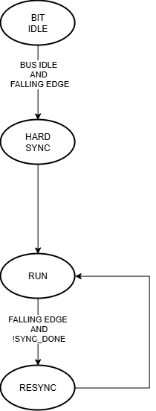

6.1.2 Timing Segments and Configuration Limits
The nominal CAN bit is divided into four non-overlapping segments. SYNC_SEG is fixed at one TQ. The sample point occurs at the boundary between PHASE_SEG1 and PHASE_SEG2.
Timing Parameter | Allowed / Fixed Value | Function
SYNC_SEG | 1 TQ (fixed) | Synchronizes nodes to an observed bus edge.
PROP_SEG | 1–8 TQ | Compensates for propagation delay in the network.
PHASE_SEG1 | 1–8 TQ | Phase-buffer segment before the sample point; may be extended during early resynchronization.
PHASE_SEG2 | 1–8 TQ | Phase-buffer segment after the sample point; may be shortened during late resynchronization.
Total TQ per bit | 8–25 TQ | Required programmable nominal bit length from the Bosch timing material used for this specification.
SJW | 1-4 TQ. | Maximum phase correction applied during resynchronization; the correction is limited by the programmed SJW and the calculated phase error.
The total nominal bit length is the sum of the four segments. For this implementation, SYNC_SEG is fixed at 1 TQ, while the three programmable segment fields are supplied through SEGMENTS. The current RTL exposes SJW as a 4-bit field but does not hardware-enforce the CAN-defined range; software is responsible for programming a legal value

6.1.3 Bit-Timing Calculations
Use the following equations to derive the nominal CAN timing from the programmed BRP and segment values. T_CAN_CLK is the period of CAN_CLK.
Calculation | Definition / Use
T_CAN_CLK = 1 / CAN_CLK | Period of the CAN controller clock.
TQ = BRP × T_CAN_CLK | Duration of one Time Quantum. BRP = 1 produces one TQ per CAN_CLK period.
TQ_BIT = 1 + PROP_SEG + PHASE_SEG1 + PHASE_SEG2 | Total number of TQs in one nominal CAN bit. The Bosch timing material requires 8–25 TQ per bit.
T_BIT = TQ_BIT × TQ | Nominal CAN bit time.
CAN_BIT_RATE = CAN_CLK / (BRP × TQ_BIT) | Nominal CAN bus bit rate produced by the programmed timing.
CAN_CLK = CAN_BIT_RATE × BRP × TQ_BIT | Required CAN_CLK for a selected bit rate, BRP and total TQ count.
Sample Point (%) = [(1 + PROP_SEG + PHASE_SEG1) / TQ_BIT] × 100 | Sample point occurs at the end of PHASE_SEG1, at the boundary with PHASE_SEG2.
Early edge: phase_error = TQ_COUNT | Used when TQ_COUNT < sample_point.
Late edge: phase_error = TQ_BIT − TQ_COUNT | Used when TQ_COUNT > sample_point.
At sample point: phase_error = 0 | No phase correction when TQ_COUNT = sample_point.
correction = min(phase_error, SJW) | Limits the resynchronization correction to the configured Synchronization Jump Width.
Implementation behavior: for an early edge, PHASE1_CURRENT is increased by correction and PHASE2_CURRENT remains nominal. For a late edge, PHASE2_CURRENT is decreased by correction and PHASE1_CURRENT remains nominal. The runtime values return to the programmed nominal values at the normal bit boundary.

6.1.4 Example: 1 Mbps at 8 MHz CAN_CLK
The 8 MHz configuration is the minimum-clock example for 1 Mbps when BRP = 1 and the nominal bit uses the minimum allowed 8 TQ.
Parameter | Value
CAN_CLK | 8 MHz
CAN_BIT_RATE | 1 Mbps
BRP | 1
SYNC_SEG | 1 TQ
PROP_SEG | 2 TQ
PHASE_SEG1 | 3 TQ
PHASE_SEG2 | 2 TQ
TQ_BIT | 8 TQ
TQ period | 125 ns
Bit time | 1 µs
Sample Point | 75%
SJW | 2 TQ
Verification: 1 + 2 + 3 + 2 = 8 TQ and 8 MHz / (1 × 8) = 1 Mbps.

6.1.5 Example: 1 Mbps at 100 MHz CAN_CLK
The 100 MHz configuration uses BRP = 5 and 20 TQ per nominal bit. This remains inside the 8–25 TQ requirement while allowing an exact 1 Mbps bus rate.
Parameter | Value
CAN_CLK | 100 MHz
CAN_BIT_RATE | 1 Mbps
BRP | 5
SYNC_SEG | 1 TQ
PROP_SEG | 7 TQ
PHASE_SEG1 | 8 TQ
PHASE_SEG2 | 4 TQ
TQ_BIT | 20 TQ
TQ period | 50 ns
Bit time | 1 µs
Sample Point | 80%
SJW | 2 TQ
Verification: 1 + 7 + 8 + 4 = 20 TQ and 100 MHz / (5 × 20) = 1 Mbps.

6.1.6 Multi-Node Timing Compatibility
- All nodes connected to the same CAN bus must operate at the same nominal bus bit rate. They do not need to use identical BRP or segment register values when their local CAN_CLK frequencies differ.
- Each node may select a different BRP and total TQ count appropriate to its local clock, provided the resulting nominal bit rate is the same and the programmed timing remains within the specified CAN timing constraints.
- For example, an 8 MHz node can use BRP = 1 and 8 TQ/bit, while a 100 MHz node can use BRP = 5 and 20 TQ/bit. Both produce 1 Mbps. The resulting sample point and phase timing should also be selected to remain compatible across the network.
Important: the 8–100 MHz range is a specification-level operating target. Not every clock frequency between these limits necessarily has an exact 1 Mbps integer solution with BRP and TQ_BIT constrained to the implemented/programmed ranges.

6.2 Transmit Path
A frame is loaded through TX_ID, TX_CTRL, TX_DATA_LO/HI, then submitted by writing bit 0 of TX_COMMAND. The request crosses to the CAN domain through can_tx_cdc as a single outstanding descriptor (p_tx_pending is held until the CAN domain acknowledges it); only one frame can be queued at a time — there is no multi-frame TX queue/mailbox (Section 10).
On the CAN side, tx_buffer captures the descriptor into a holding register once the bus is idle (tx_valid && !line_busy), and presents the data byte selected by the current byte_idx. Byte ordering is DLC-relative and right-justified in the 64-bit TX_DATA register: for a given DLC = N, the first byte transmitted is bits [(8N−1):(8N−8)] of TX_DATA and the last byte transmitted is always TX_DATA[7:0]. For example, with DLC = 3 the three bytes sent are TX_DATA[23:16], TX_DATA[15:8], TX_DATA[7:0], in that order.
tx_datapath serializes the SOF, arbitration (ID/RTR/IDE/r1/r0), control (r0/r1 and DLC), and data fields bit-by-bit according to the frame controller's current field/bit position; the CRC field is supplied by the transmit CRC generator instead (Section 6.5). The serialized stream passes through the bit stuffer (Section 6.4) before being driven onto can_tx. can_tx is forced recessive (1) in IDLE and whenever LISTEN_ONLY is set, and is forced dominant (0) whenever this node is acting as receiver and driving the ACK slot (Section 6.6).
Automatic retransmission: if an error event occurs while this node is transmitting (and the node is not in bus-off and not already in bus-off recovery), the pending-transmission flag is re-asserted so the same frame is retried automatically once the bus returns to IDLE. There is no host-selectable "single-shot" (transmit-once, no automatic retry) mode.
Transmitter delay of retransmission (suspend transmission): a node whose error state is Error Passive, after completing a successful transmission, inserts an 8-bit SUSPEND_TRANSMISSION field after INTERMISSION before it may again contend for the bus (implemented as a dedicated state, Section 7.1); the suspend is aborted early if the bus goes dominant (another node starting a frame).
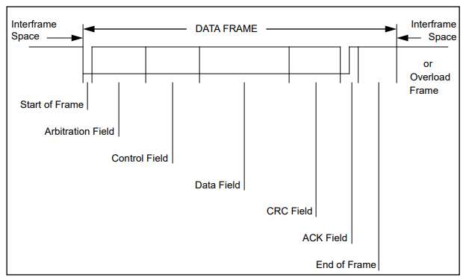
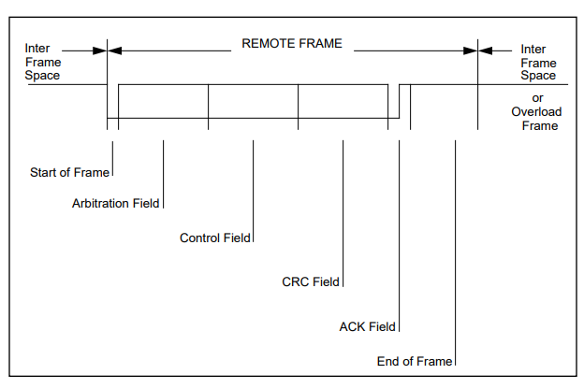

6.3 Receive Path
can_rx_datapath deserializes the identifier (base 11 bits, and extension 18 bits for extended frames), RTR, IDE, DLC, and data fields as the frame controller advances through the bit-timing–qualified bit stream (destuffed bits only, rx_bit_valid). Data-byte capture follows the same DLC-relative, right-justified convention as the transmit path (Section 6.2). rx_frame_valid is asserted for one can_clk cycle at the last bit of EOF; because any error event forces an immediate transition to ERROR_FLAG (Section 6.8) before EOF is reached, rx_frame_valid — and therefore the frame ultimately presented to the acceptance filter — only ever represents a frame that has passed CRC, form, stuff and (for a remote/data exchange) has been fully clocked in without a bit error being flagged against this node as receiver.
A frame for which rx_frame_valid is asserted is passed to the acceptance filter (Section 6.10); if accepted, it is written into the RX FIFO (Section 6.11) — unless this node is simultaneously transmitting, in which case the frame is not queued for the host except in loopback mode (Section 6.9).

6.4 Bit Stuffing / De-stuffing
Standard bit stuffing (insert-after-5) is applied from SOF through the end of the CRC field on transmit, and the matching rule is used to detect and remove stuff bits on receive; both can_stuffer and can_destuffer track a running count of consecutive identical bits seen since the field began. can_stuffer inserts a stuff bit of the opposite polarity once five consecutive identical bits have been transmitted, and restarts its run-length count at 1 on the inserted bit. can_destuffer mirrors this: once five consecutive identical received bits have been counted, the next received bit is consumed as the stuff bit (not presented as data — rx_bit_valid is deasserted for it) and is checked against the expected opposite polarity; if it instead matches the run (a sixth consecutive identical bit), stuff_error is asserted. Stuffing/destuffing is enabled by the frame controller only for the SOF, ARBITRATION, CONTROL, DATA, CRC and RX_ONLY states; the CRC delimiter, ACK, ACK delimiter, EOF and intermission fields are fixed-format and unstuffed.

6.5 CRC
Both the transmit and receive paths use the same crc module: a 15-bit LFSR implementing the CAN CRC-15 polynomial x15+x14+x10+x8+x7+x4+x3+1 (0x4599), shifting in one bit per bit_en pulse across SOF through the end of the data field (crc_en is asserted for SOF, ARBITRATION, CONTROL, DATA, RX_ONLY, and for the first bit of the CRC state to flush the final value). On transmit, the accumulated 15-bit result is shifted out MSB-first as the CRC field. On receive, the same computation is run over the received (destuffed) bit stream; crc_error is asserted if the LFSR does not evaluate to zero once the 15-bit received CRC field has been fully shifted in (standard "append received CRC and check for zero remainder" method). The CRC computation excludes the frame's own CRC field on the transmit side implicitly (crc_en is not set during the CRC state itself, except to receive/shift the final comparison) and is not accumulated across stuffed bits (crc_en is qualified by !stuff_insert on transmit and by rx_bit_valid on receive).
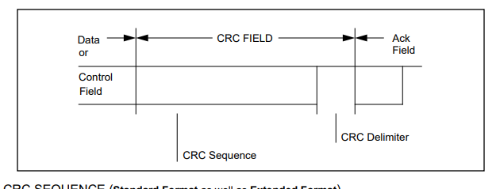

6.6 Arbitration
This node participates in arbitration by driving its own dominant/recessive identifier and arbitration bits onto can_tx while simultaneously sampling can_rx. The frame controller declares an arbitration loss (arbitration_lost) when, while in the ARBITRATION state and transmitting, the bit comparator (Section 6.7) reports a mismatch — i.e., this node drove a recessive bit but observed a dominant bit on the bus, meaning another node is transmitting a higher-priority arbitration bit. On loss, the controller immediately stops driving (is_transmitting is cleared) and transitions to the RX_ONLY state to continue receiving the winning frame from the current bit position, rather than restarting reception from SOF. Arbitration loss is treated as a normal, non-destructive bus event: it does not increment TEC/REC and is recorded separately from CAN errors (ERROR_STATUS LAST_ERROR_TYPE = 6, Section 6.8).
Standard-frame/extended-frame arbitration is implemented according to the Bosch CAN arbitration scheme. For identical 11-bit base identifiers, a standard frame transmits its RTR bit at the arbitration position immediately following the Base ID, while an extended frame transmits the Substitute Remote Request (SRR) bit at the same position. The SRR bit is always recessive. Therefore, when a standard data frame and an extended frame have the same 11-bit base identifier, the standard frame transmits dominant RTR = 0 while the extended frame transmits recessive SRR = 1, causing the standard frame to win arbitration. The SRR bit therefore preserves the priority of a standard frame over an extended frame with the same 11-bit base identifier without requiring a separate arbitration mechanism. After the SRR position, the extended frame continues with the IDE bit, the remaining 18 bits of the extended identifier, and the RTR bit.
For two frames with the same identifier, a data frame (RTR = 0, dominant) wins arbitration over a remote frame (RTR = 1, recessive) requesting the same identifier. These arbitration outcomes result directly from the bit-for-bit dominant-over-recessive comparison and are not special-cased in the RTL.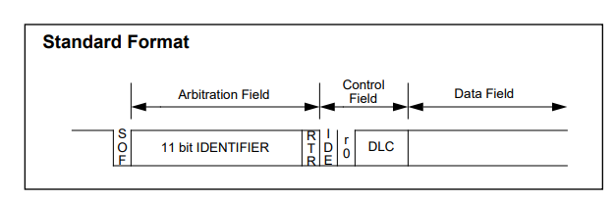
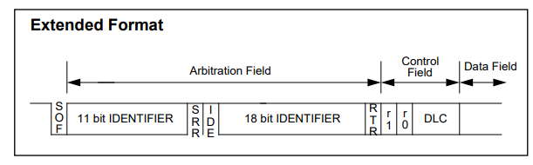
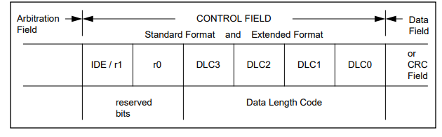

6.7 Acknowledgement
The ACK field is two bits: ACK slot and ACK delimiter. While this node is the transmitter, it drives both bits recessive and samples the ACK slot: a dominant sample sets ack_received; a recessive sample (no other node acknowledged) sets ack_error, which feeds fault confinement as a transmit error (Section 6.8). While this node is the receiver of a frame it has accepted through CRC/stuffing/form checks, the frame controller drives can_tx dominant for exactly the ACK slot bit (ack_drive), then releases the bus (recessive) for the ACK delimiter — implementing the standard receiver-acknowledges-if-frame-was-error-free-so-far behavior. A receiving node does not drive ACK while the controller is in bus-off.
The bit-error comparator (bit_error_detector) that underlies both arbitration-loss and general bit-error detection explicitly excludes the ACK state from comparison, since the bit driven by the transmitter (recessive) and the bit expected on the bus (dominant, from an acknowledging receiver) legitimately differ there.
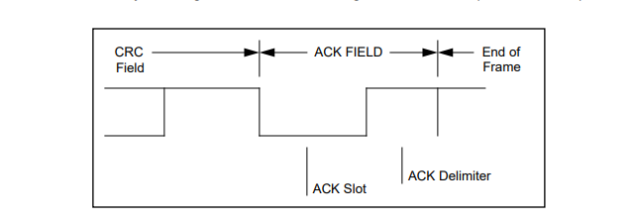

6.8 Fault Confinement and Error Handling
error_controller implements the five CAN error types (bit, stuff, form, CRC, ACK) plus Bosch fault confinement using TEC and REC 9-bit/8-bit counters and a three-state error-state machine (Section 7.2):
Bosch Spec Rule | Status | Description
Rule 1 — Receiver error | Partially  Implemented | A receiver-detected error increments REC by 1, with the applicable error-flag exception implemented. OVERLOAD FLAG-specific behavior is not implemented because OVERLOAD frames are outside the current design scope.
Rule 2 — First dominant bit after ERROR FLAG | Implemented | The first dominant bit detected after the node has transmitted an ERROR FLAG causes REC to be incremented by 8.
Rule 3 — Transmitter ERROR FLAG | Implemented | A transmitter-side error increments TEC by 8, with the Bosch-defined exceptions implemented.
Rule 3, Exception 1 — Error-passive ACK error | Implemented | An ACK error detected by an Error-Passive transmitter during the ACK field is excluded from the normal TEC +8 update.
Rule 3, Exception 2 — Arbitration-field stuff error | Implemented | The specified arbitration-field stuff-error condition is excluded from the normal TEC +8 update.
Rule 4 — Transmitter bit error during ERROR FLAG / OVERLOAD FLAG | Partially  Implemented | The transmitter-side dominant-bit/error-flag handling is implemented through the dominant_error_plus8 mechanism and TEC update logic. OVERLOAD FLAG behavior is not implemented because OVERLOAD frames are unsupported.
Rule 5 — Receiver bit error during ERROR FLAG / OVERLOAD FLAG | Partially  Implemented | Receiver-side bit-error handling during error-flag transmission is implemented through the receiver error exception and REC update logic. OVERLOAD FLAG behavior is not implemented because OVERLOAD frames are unsupported.
Rule 6 — Dominant-bit error-flag extension | Partially implemented | Dominant-bit counting and the corresponding TEC/REC +8 behavior for active and passive ERROR FLAG conditions are implemented. OVERLOAD FLAG behavior is not implemented because OVERLOAD frames are unsupported.
Rule 7 — Successful transmission | Implemented | TEC is decremented by 1 after successful transmission, with a floor of zero.
Rule 8 — Successful reception | Implemented | REC is decremented according to the Bosch rule, including the special handling when REC is greater than 127.
Rule 9 — Error Passive transition | Implemented | The node enters ERROR_PASSIVE when TEC or REC reaches 128 or greater.
Rule 10 — Bus Off transition | Implemented | The node enters BUS_OFF when TEC reaches 256.
Rule 11 — Error Passive to Error Active | Implemented | The node returns to ERROR_ACTIVE when both TEC and REC are less than or equal to 127.
Rule 12 — Bus-Off recovery | Implemented | Recovery requires 128 occurrences of 11 consecutive recessive bits. After successful recovery, the node returns to ERROR_ACTIVE and TEC/REC are cleared.
OVERLOAD Frame Limitation: Bosch Section 8 contains fault-confinement rules that explicitly refer to an OVERLOAD FLAG. The current controller does not generate or detect OVERLOAD frames. Therefore, the OVERLOAD-specific portions of the fault-confinement behavior are not implemented. This is a deliberate scope limitation of the current CAN 2.0B controller
Error flag: When any error event or explicit error-flag request occurs and the node is not already handling an error flag and is not in BUS_OFF, the frame controller transitions into the error-flag sequence. It transmits a 6-bit error flag, dominant in ERROR_ACTIVE and recessive in ERROR_PASSIVE, followed by WAIT_RECESSIVE and the 8-bit error delimiter before normal INTERMISSION resumes..
- ERROR_ACTIVE: normal operation. Transitions to ERROR_PASSIVE when TEC or REC exceeds 127; transitions directly to BUS_OFF if TEC reaches 256.
- ERROR_PASSIVE: node still participates in the bus and transmits passive (recessive) error flags, but may only initiate a new transmission after inserting the suspend-transmission field. Returns to ERROR_ACTIVE once both TEC ≤ 127 and REC ≤ 127. Transitions to BUS_OFF if TEC reaches 256.
- BUS_OFF: the node stops driving the bus and stops counting new errors. recovery_active is asserted for the duration. Recovery requires observing 128 occurrences of 11 consecutive recessive bits (implemented as a count of 10 further recessive bits after each recessive edge, repeated 127 times, i.e. 128 sequences total including the first) on the bus before returning to ERROR_ACTIVE with TEC = REC = 0.
Every latched error/event (five CAN error types plus arbitration-lost as a sixth, non-error event code) is captured by can_error_latch into a single "last error" record (type + valid flag) with a toggling event strobe; only the most recent event's type is visible in ERROR_STATUS — if multiple different error types occur close together, earlier ones are overwritten before the host polls (see Section 10).
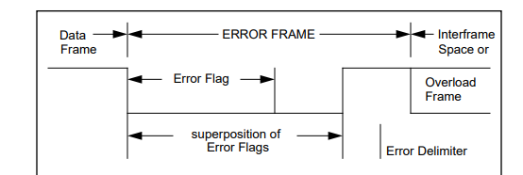

6.9 Operating Modes
- Normal: CAN_ENABLE = 1, LOOPBACK = 0, LISTEN_ONLY = 0. can_tx drives the physical bus normally; can_rx is taken from the external pin.
- Loopback: LOOPBACK = 1. The controller's RX path is fed from its own can_tx output rather than the external can_rx pin, except during the ACK state, where the internal RX path is forced dominant so the node acknowledges its own transmitted frame (since no external transceiver/bus is required to supply the ACK). A loopback-received, accepted frame is queued into the RX FIFO like any other received frame. LOOPBACK and LISTEN_ONLY cannot be set together (Section 5).
- Listen-only: LISTEN_ONLY = 1. can_tx is forced recessive at the pad regardless of internal protocol state, so this node never drives the bus, including never driving the ACK slot; it can still receive, run its protocol state machine, and update TEC/REC/error state from what it observes, but cannot influence the bus.

6.10 Acceptance Filtering
can_acceptance_filter implements two independent mask/ID filters, each with its own 29-bit ID, 29-bit mask (1 = compare, 0 = don't-care), an enable bit, and a required IDE value. A received, error-free frame (rx_frame_valid) is accepted if either: (a) both filters are disabled, in which case every valid frame is accepted, or (b) at least one enabled filter's IDE matches the frame's IDE and (identifier AND mask) matches (filter ID AND mask). The two filters are logically OR'd — a frame accepted by either filter is queued once. Filter registers can only be written while CAN_ENABLE = 0 (Section 5).

6.11 RX FIFO
Accepted frames are packed into a 128-bit word (5 bits unused/zero, 29-bit ID, IDE, RTR, 4-bit DLC, 64-bit data) and written into a dual-clock async_fifo (Gray-code pointers, FIFO_DEPTH entries, instantiated inside can_rx_fifo_bridge) on the can_clk side; the host reads the frame at the head of the FIFO through RX_ID/RX_CTRL/RX_DATA_LO/HI and advances the FIFO by writing RX_COMMAND. A write is suppressed while the FIFO is full and instead sets the sticky fifo_overflow flag (Section 5, Section 10). A frame is not written to the FIFO while this node is transmitting, unless LOOPBACK is set (Section 6.9).

7. FSM / State Transitions
The RTL contains two state machines: the main protocol/frame-sequencing FSM in can_frame_controller, and the three-state fault-confinement FSM in error_controller (the clock-domain-crossing blocks use toggle/handshake registers rather than an enumerated state register, and the async FIFO uses standard Gray-code read/write pointers).

7.1 Protocol / Frame Controller FSM (can_frame_controller)
4-bit state register field_sel, 16 encoded states (0–15). From any state other than ERROR_FLAG, WAIT_RECESSIVE or ERROR_DELIM, an error event or an explicit error-flag request forces an immediate transition to ERROR_FLAG (shown once here rather than repeated per state below); this pre-emption is checked first, ahead of the per-state transitions listed in the table.
# | State | Function | Transition(s)
0 | IDLE | Bus idle; can_tx recessive. | A dominant bus edge or SOF detection → ARBITRATION (this node becomes a receiver). Else if TX_COMMAND is pending and not in bus-off → SOF (this node becomes transmitter).
1 | SOF | Transmitter only: drives the dominant SOF bit. | Next bit_en → ARBITRATION.
2 | ARBITRATION | Serialize/sample the 11-bit base ID (+RTR/IDE for standard, or continue into the 18-bit extension for extended, ARB_PHASE2), comparing driven vs. observed bits. | If transmitting and bit_error is detected → RX_ONLY: clear is_transmitting and continue receiving from the current arbitration position. If receiving and rx_bit_valid = 0 → remain in ARBITRATION and hold bit_cnt. If transmitting and stuff_insert = 1 → remain in ARBITRATION and hold bit_cnt. At the end of phase 1, TX uses IDE and RX uses sampled can_rx_sync to select standard or extended operation. Standard → CONTROL with bit_cnt = 5; extended → remain in ARBITRATION with arb_phase = 1 and bit_cnt = 19. At the end of phase 2 → CONTROL with bit_cnt = 6 and active_ide = 1.
3 | CONTROL | Serialize/sample r1/r0 and DLC (5 bits standard / 6 bits extended). | At the last control bit: TX RTR = 1 or TX DLC = 0 → CRC; otherwise → DATA. On RX, rx_rtr = 1 or the received DLC evaluates to zero → CRC; otherwise → DATA.
4 | DATA | Serialize/sample data bytes, byte_idx advancing each 8 bits. | If RX and rx_bit_valid = 0, hold. If TX and stuff_insert = 1, hold. After the final configured byte → CRC; otherwise reload 8 bits and continue DATA.
5 | CRC | Serialize/sample the 15-bit CRC field. | If RX and rx_bit_valid = 0, hold. If TX and stuff_insert = 1, hold. At the last CRC bit → CRC_DELIM.
6 | CRC_DELIM | Fixed recessive delimiter bit. | Next bit_en → ACK.
7 | ACK | Transmitter samples the ACK slot; receiver drives it dominant. | Next bit_en → ACK_DELIM.
8 | ACK_DELIM | Fixed recessive delimiter bit. | Next bit_en → EOF.
9 | EOF | 7-bit end-of-frame field; tx_done/rx_done pulse on the last bit. | At the last EOF bit → INTERMISSION.
10 | INTERMISSION | 3-bit fixed recessive gap. | At the last bit: if this node just finished transmitting while Error Passive → SUSPEND_TRANSMISSION; else → IDLE.
11 | ERROR_FLAG | 6-bit error flag (dominant if Error Active, recessive if Error Passive). | At the last flag bit → WAIT_RECESSIVE.
12 | WAIT_RECESSIVE | Hold until the bus is observed recessive (bus-idle-recovery wait, of unbounded length). | Once the sampled bus is recessive, next bit_en → ERROR_DELIM.
13 | ERROR_DELIM | 8-bit fixed recessive delimiter. | At the last bit → INTERMISSION.
14 | RX_ONLY | Continue receiving (arbitration/ID phase) after this node has lost arbitration, without restarting from SOF. | If rx_bit_valid = 0 → hold. At the end of phase 1, sampled can_rx_sync selects standard → CONTROL with bit_cnt = 5 or extended → ARB_PHASE2 with bit_cnt = 19. At the end of phase 2 → CONTROL with bit_cnt = 6.
15 | SUSPEND_TRANSMISSION | 8-bit gap inserted by an Error-Passive node after its own successful transmission, before it may contend for the bus again. | A dominant bus edge during the suspend → ARBITRATION (another node started a frame). Else, at the last suspend bit → IDLE.

Notes: bit_cnt down-counts the remaining bits of the current field and is reloaded on each state entry (13 for arbitration phase 1, 19 for phase 2, 5/6 for control, 15 for CRC, 7 for EOF, 3 for intermission, 6 for the error flag, 8 for the error delimiter and for suspend-transmission). Field durations are held (next_state = present_state, bit count unchanged) while waiting for a de-stuffed receive bit to become valid, or while a transmitted stuff bit is being inserted, so that stuff bits do not consume a protocol bit position.
The frame-controller FSM has 16 states. BUS_OFF is not a frame-controller state; it is one of the three error_controller states and inhibits normal transmission through error-state gating. Arbitration priority is not implemented as a separate priority FSM: the dominant-wins result emerges from the bit-level comparison between the driven and observed bus values.
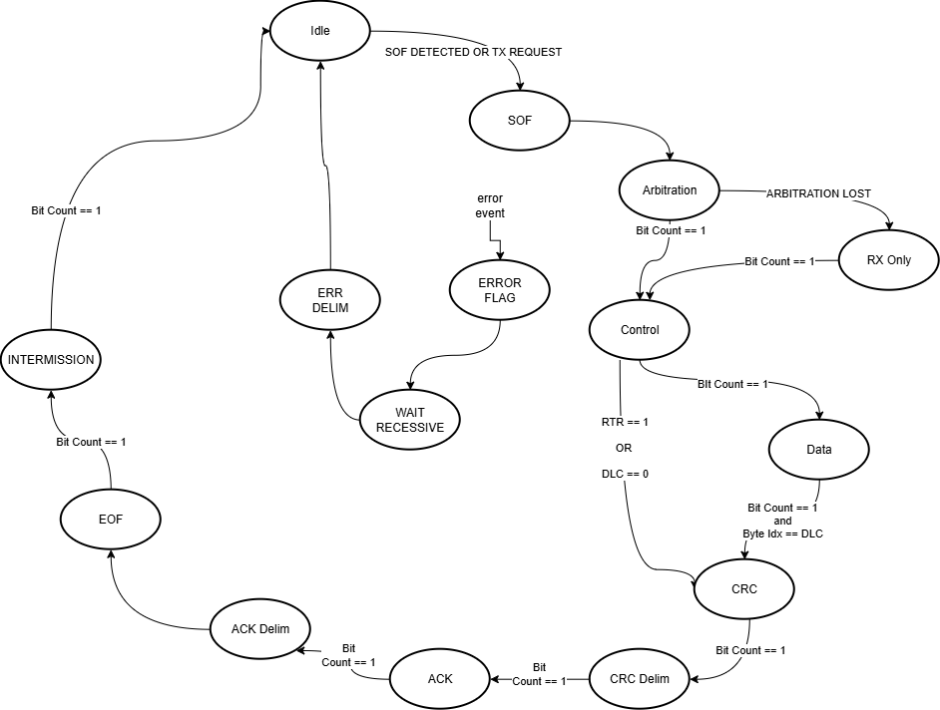

7.2 Fault-Confinement FSM (error_controller)
# | State | Function | Transition(s)
0 | ERROR_ACTIVE | Normal operation; this node's own error flags are dominant. | TEC ≥ 256 → BUS_OFF. Else TEC > 127 or REC > 127 → ERROR_PASSIVE. Else remain ERROR_ACTIVE.
1 | ERROR_PASSIVE | Node participates normally but sends passive (recessive) error flags and must suspend after its own successful transmissions. | TEC ≥ 256 → BUS_OFF. Else TEC ≤ 127 and REC ≤ 127 → ERROR_ACTIVE. Else remain ERROR_PASSIVE.
2 | BUS_OFF | Node does not drive the bus; TEC/REC hold; recovery_active = 1. | After observing 128 occurrences of 11 consecutive recessive bits (counted as 10 further recessive bits following each recessive edge, repeated 127 times) → ERROR_ACTIVE with TEC = REC = 0.
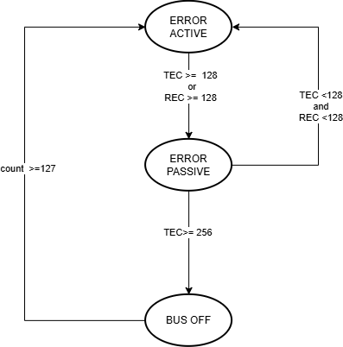

8. Reference Specification and Supported Features
Reference Specification: Bosch CAN 2.0B Specification (ISO 11898-1 protocol layer).
Feature | Supported
Standard data frame (11-bit identifier) | Yes
Extended data frame (29-bit identifier, base + extension) | Yes
Standard/extended remote frame (RTR) | Yes — transmit and receive
Bit stuffing / de-stuffing (5-consecutive-bit rule, SOF..CRC) | Yes
CRC-15 generation and checking (polynomial 0x4599) | Yes
Bit-for-bit arbitration, non-destructive, ID-priority + RTR/IDE tie-break | Yes
Acknowledge slot drive (receiver) and check (transmitter) | Yes
Configurable bit timing: PROP_SEG, PHASE_SEG1, PHASE_SEG2, SJW, BRP | Yes, fully register-programmable
Hard synchronization at SOF | Yes
Resynchronization (soft sync) with SJW-limited phase correction | Yes
Fault confinement: error-active / error-passive / bus-off | Yes
Error counters TEC/REC with Bosch increment/decrement rules | Yes (see Section 6.8 for the two exception cases implemented)
Bus-off recovery (128 × 11 consecutive recessive bits) | Yes
All five error types: bit, stuff, form, CRC, ACK | Yes
Active and passive error flags, error delimiter | Yes
Suspend transmission (Error Passive nodes) | Yes
Automatic retransmission on error | Yes (always on; not host-configurable)
"Single-shot" transmission (send once, no automatic retry) | No
Overload frame generation/detection | No
Hardware acceptance filtering | Yes — two independent mask/ID filters, OR'd
Receive FIFO / frame buffering | Yes — dual-clock FIFO, depth = FIFO_DEPTH
Multiple pending transmit frames (TX mailbox/queue) | No — one TX descriptor at a time
Loopback (self-test) mode | Yes
Listen-only (bus-monitor) mode | Yes
Interrupt output | No — status is register-polled only
CAN FD (flexible data-rate) | No — this design is CAN 2.0B only

9. Parameters
Parameter | Used in | Default | Effect
CAN_CLK_FREQ | can_controller_top, can_controller, bit_timing_engine | 100,000,000 | Declared and passed down through the module hierarchy to bit_timing_engine, but not referenced by any logic in that module (or anywhere else). It has no effect on simulation or synthesized behavior; the effective can_clk frequency and CAN bit rate are entirely determined at run time by the CAN_ENABLE/BRP/PROP_SEG/PHASE_SEG1/PHASE_SEG2/SJW registers (Section 6.1). Present for documentation/integration reference only.
CAN_BIT_RATE | can_controller_top, can_controller, bit_timing_engine | 1,000,000 | Same status as CAN_CLK_FREQ: propagated but not used by any logic. No effect on behavior.
FIFO_DEPTH | can_controller_top, can_rx_fifo_bridge, async_fifo | 8 | Number of complete received frames the RX FIFO (Section 6.11) can hold. Sets the async FIFO's DEPTH, from which its internal pointer width is derived as $clog2(FIFO_DEPTH)+1. The RX_STATUS/STATUS FIFO_COUNT field and the FIFO's internal fifo_count port are fixed at 4 bits regardless of this parameter, which limits accurately representable depths to FIFO_DEPTH ≤ 16 (Section 10).
ADDR_WIDTH | can_apb_slave | 12 | Width of PADDR. The register map in Section 5 uses 12-bit (word-aligned) offsets up to 0x068; this parameter would need to grow only if the register map were extended.
ID_WIDTH | can_acceptance_filter | 29 | Width of the identifier/mask compared by each acceptance filter; fixed to the CAN 2.0B extended identifier width.

10. Known Limitations
- Single TX descriptor: only one frame can be staged for transmission at a time (TX_ID/TX_CTRL/TX_DATA plus the single-outstanding TX CDC handshake). There is no TX mailbox/queue; the host must wait for TX_DONE/TX_ERROR before loading and submitting the next frame.
- No single-shot transmit mode: automatic retransmission on error is always enabled and cannot be disabled by the host.
- Overload frames are neither generated nor detected.
- DLC values 9–15 are accepted by TX_CTRL/observed on the bus for RX, but the byte-indexing logic in tx_buffer and can_rx_datapath only implements DLC 1–8; byte_idx itself is only 3 bits wide (0–7). A frame with DLC coded 9–15 will not be clamped to 8 data bytes by hardware, and the data-capture/selection logic for byte positions beyond 8 is undefined (not implemented) rather than saturated. Software should not program TX_DLC outside 0–8, and should treat RX_DLC values above 8 as not reliably reflected in RX_DATA.
- BRP = 0 is not a usable value: the divider compares brp_count against BRP−1, so BRP = 0 produces an effective divide of 2^32 rather than a fault or a divide-by-one; hardware does not reject or flag BRP = 0.
- No bit-timing range checking: BRP, PROP_SEG, PHASE_SEG1, PHASE_SEG2, and SJW are not hardware range-checked against the CAN 2.0B legal/recommended ranges. For SJW specifically, CAN 2.0B requires 1 ≤ SJW ≤ min(4, PHASE_SEG1). Software must ensure legal programming.
- Most live error/status bits in STATUS (ARB_LOST, ACK_ERROR, CRC_ERROR, STUFF_ERROR, FORM_ERROR, BIT_ERROR) are single-cycle pulses synchronized once into the pclk domain, not sticky flags; a host polling STATUS can miss one if it does not sample on the exact cycle it is valid. ERROR_STATUS/LAST_ERROR_TYPE is latched, but records only the single most recent error/event — if multiple different error types occur in close succession, only the last is visible.
- RX_OVERFLOW (STATUS/RX_STATUS bit 10) is a sticky flag that is only ever set by hardware, never cleared; the only way to clear it is a reset of the CAN_CLK domain.
- The async RX FIFO's fifo_count output is a fixed 4-bit port regardless of the FIFO_DEPTH parameter, so FIFO_COUNT in RX_STATUS/STATUS is only meaningful for FIFO_DEPTH ≤ 16.
- Only two acceptance filters are provided, each a single mask/ID pair, OR'd together; there is no filter list, range filter, or per-filter FIFO routing.
- No interrupt output: all status, error and RX-available information must be polled through the APB register map; there is no way for the host to be signaled asynchronously of a new event.
- Loopback mode reflects the node's own transmitted bits back to its own receiver (with the ACK slot forced dominant); it does not model arbitration, another node's ACK behavior, or bus contention, and is not a substitute for testing against a second physical or simulated CAN node.
- This design implements CAN 2.0B (classic CAN) only; CAN FD (flexible data-rate, larger payloads, BRS) is not implemented and is out of scope.
- The APB slave is a fixed zero-wait-state design (PREADY is always driven 1'b1); it assumes a host that can complete a register access in a single APB access phase.
- CAN_CLK_FREQ and CAN_BIT_RATE are unused RTL parameters; integrators should not rely on them to configure timing — actual timing is entirely register-programmed (Section 6.1, Section 9).

